Recommendations for the assessment of cardiac calcification on routine thoracic CT.
From “Reporting incidental coronary, aortic valve and cardiac calcification on non-gated thoracic computed tomography, a consensus statement from the BSCI/BSCCT and BSTI”
Practice Guideline; Br J Radiol. 2021 Jan 1;94 Michelle Claire Williams et al.

- Recommendations
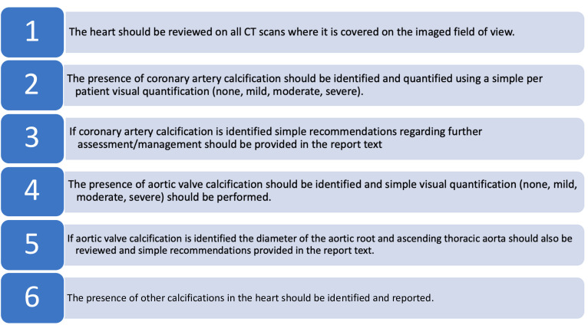

- coronary artery calcification
Flow diagram for the assessment of coronary artery calcification on routine thoracic CT.
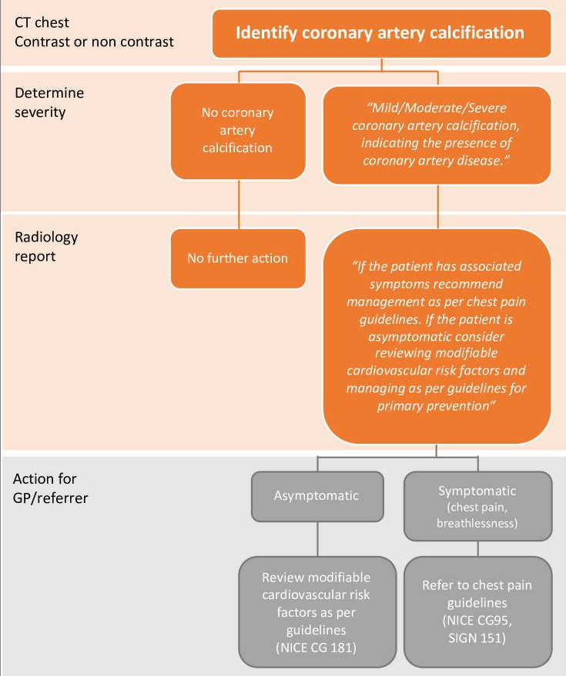
If Coronary Artery calcification is identified use the RCHT existing CRIS shortcut code:
“GET CORONARY CALCIFICATION” …
(Mild / moderate / severe) coronary artery calcification is noted. If clinically appropriate we would advise reviewing addressable cardio-vascular risk factors with the patient in primary care. Further testing or assessment for those without symptoms may not be necessary or recommended (see guidance on the RMS website). Please only refer for assessment those with suspected cardiac chest pain following the RACPC guidance / pathway which can be found on eRS and RCHT website.

Assessment of Coronary artery calcification severity.
Images show different severity of coronary calcification from different patients on non-contrast (A–D) and contrast enhanced CT (E–H). Images show no coronary artery calcification (A, E) and mild (B, F), moderate (C, G) and severe (D, H) coronary artery calcification.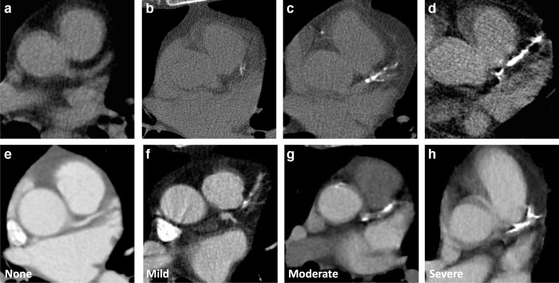

- Cardiac valve calcification
Flow diagram for the assessment of cardiac valve calcification on routine thoracic CT.

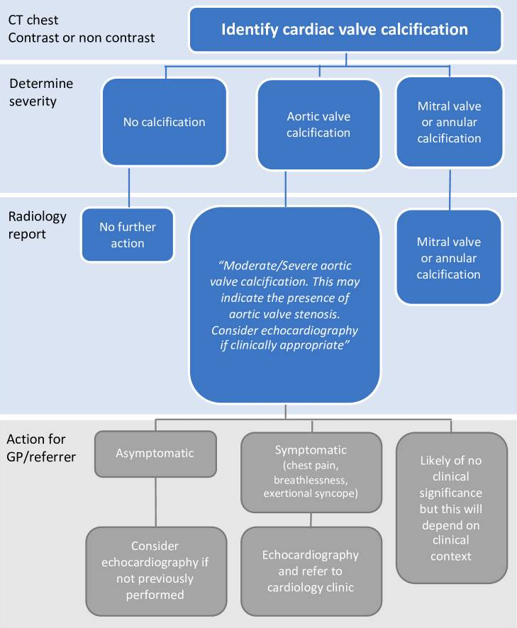

Aortic valve calcification severity.
The presence of moderate or severe aortic valve calcification may identify patients who require further assessment such as echocardiography. It may also be the cause of presenting symptoms such as dyspnoea. However, in many cases the presence of aortic valve disease will already be known, and echocardiography may have already been performed. For patients with aortic valve calcification, the diameter of the aortic root and ascending aorta should also be reviewed, on multiplanar reformats where possible, as post-stenotic dilation may be apparent even on non-contrast imaging. This is not an immediate indication for recall for contrast enhanced imaging but should prompt further assessment of the severity of the aortic stenosis and further assessment of aortic anatomy may be required.
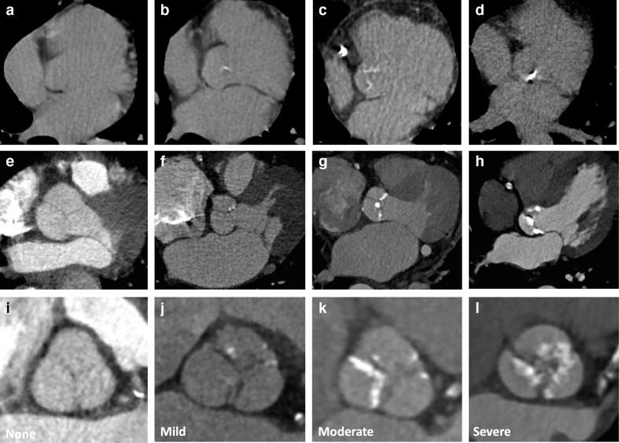
Images show different severities of aortic valve calcification from different patients on non-contrast (A–D) and contrast enhanced CT (E–L). Multiplanar reformats can help to differentiate aortic valve calcification from annular or aortic calcification (I–L). Images show no calcification (A, E, I) and mild (B, F, J), moderate (C, G, K) and severe (D, H, L) aortic valve calcification.
Short code for Aortic Valve Calcification
“Moderate/Severe aortic valve calcification is noted. This may indicate the presence of aortic valve stenosis. Consider echocardiography if clinically appropriate.”
VR command to follow…

3. Mitral Valve Calcification Severity. For information only.
Not usually frequently seen and rarely reason to refer for additional investigations.
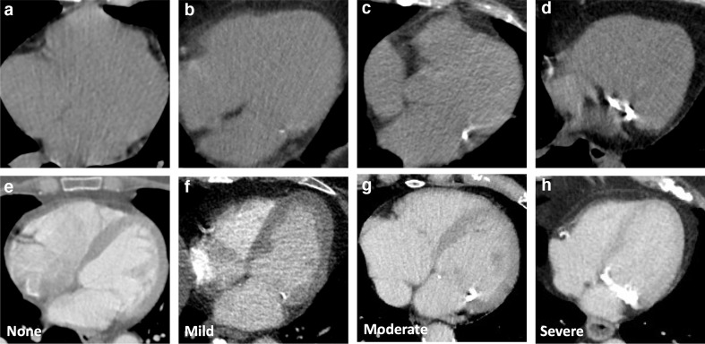
Images show different severity of mitral calcification from different patients on non-contrast (A–D) and contrast CT (E–H). Images show no calcification (A, E) and mild (B, F), moderate (C, G) and severe (D, H) calcification.

- Other Cardiac Calcification. For information only.
Not usually frequently seen and rarely reason to refer for additional investigations.
Examples of cardiac calcification in other sites including (A) pulmonary arteries, (B) papillary muscle, (C, F) myocardium and (D, E) pericardium. Image (C) shows myocardial calcification in renal failure and (F) shows myocardial calcification in an infarct. (E) shows an example of benign pericardial calcification, whereas (D) shows pericardial calcification associated with constrictive pericarditis with associated atrial enlargement, tubular ventricular morphology, pleural effusion and a distended inferior vena cava.

